One Year of Fighting Covid-19: Reflections on Posts from the First Lockdown
Miranda Curtis

As we find ourselves several months into 2021, over one year after Covid-19 began spreading worldwide, it feels surreal to reflect on the beginnings of the pandemic. The past year has been one of takeaway meals, Zoom meetings, and social distancing, an endless cycle of lockdowns and ever-shifting government guidelines. As a student, it has meant completing my entire MA degree online, never seeing my classmates in an actual classroom. I have often found myself thinking that the passing of time itself has been one of the strangest aspects of lockdown. Sometimes it feels like the entire year has passed in the blink of an eye, other times the same week seems to have stretched on for months.

Posts from the First Lockdown, an online art project that allowed artists experiencing the first round of lockdowns within China to share their artistic reactions online, offers rich examples of the emotions now characteristic of quarantine life—boredom, anxiety, anger, and more. Organized by Gaia Fugazza, Luigi Galimberti, and Sha Li, the project is not only representative of artistic reactions to Covid, but is also an important historical archive of early pandemic within China. One year later, the posts feel as relevant as ever, and worthy of reflection.

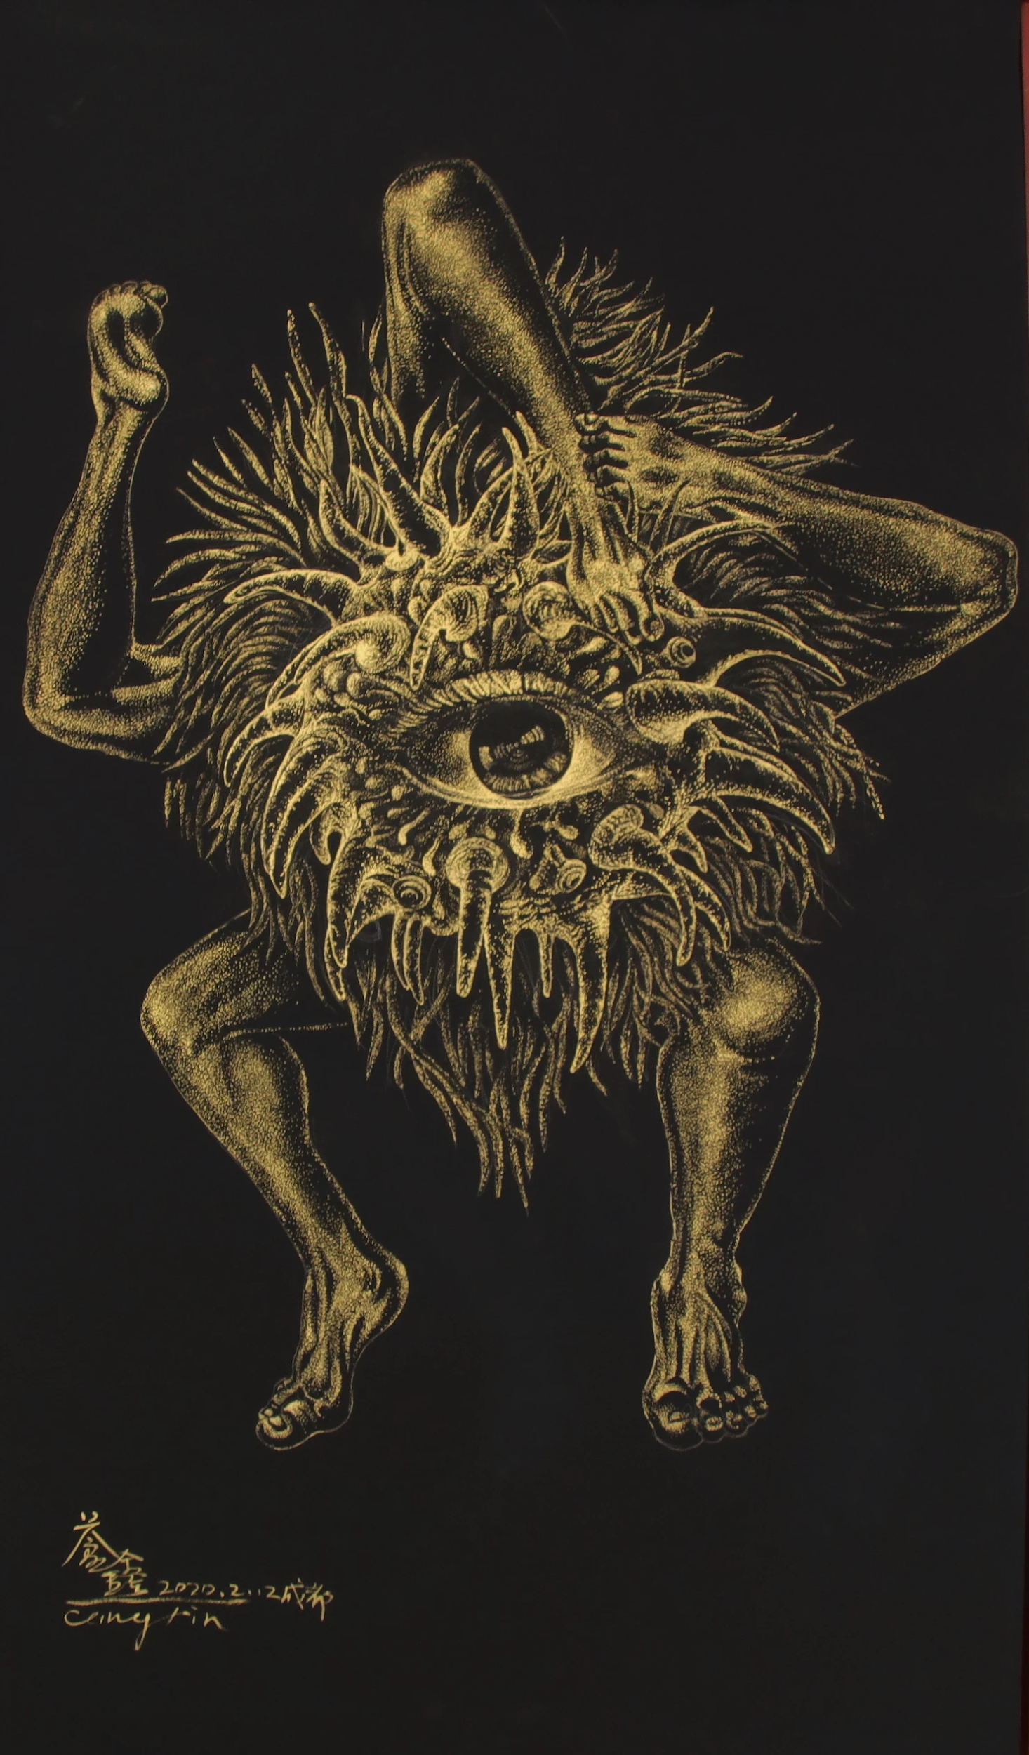
Cang Xin, Community of Mutual Harm
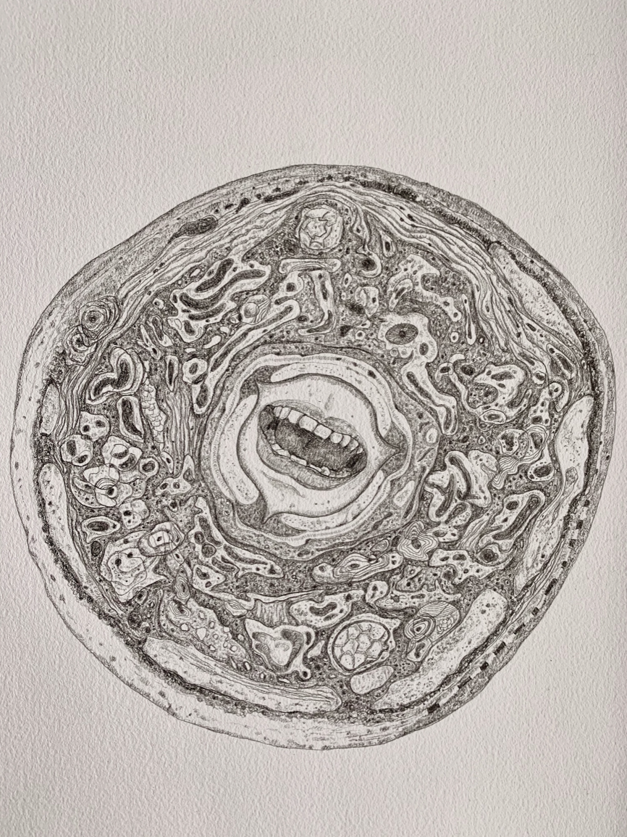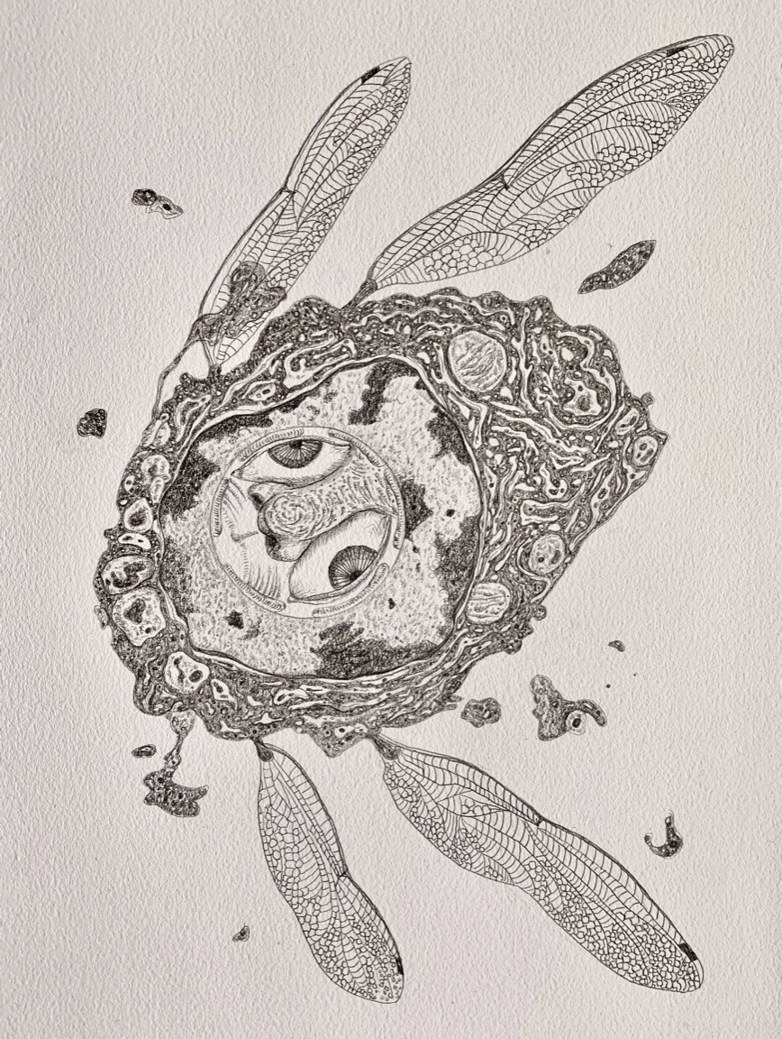
Drawings by Luo Kai

How can we fight a war when we cannot see our enemy? In China, pandemic slogans often invoke themes of war and fighting. As Feng Xiaodan points out, in government messaging Covid is often depicted as “renmin zhanzhen 人民战争 “people’s war,” zongtizhan 总体战 “total war,” and zujizhan 阻击战 “blockade.” Likewise, anti-epidemic measures often use the phrase “kangyi 抗疫”, with the word kang offering the meaning “to fight” among other translations. The act of fighting, however, implies a kind of proactive action or aggression, quite the opposite of the self-isolation and homebound lifestyles that prevent the spread of Covid. This contradictory framework, in which inaction is action, and passiveness is productive, is indicative of the oddness of life under pandemic.

For some participating artists, depicting Covid involved re-imagining the microscopic. Cang Xin’s Community of Mutual Harm and Luo Kai’s series of drawings feature enlarged cellular organisms bearing fragments of human bodies: eyes, noses, mouths. Depicted as grotesque monsters, infectious agents are rendered visible to the human eye, if only via the artistic process. Here the artists’ own imaginations have translated Covid into something picturable and fightable. The inclusion of human body parts, resulting in the creation of a kind of human-virus mutation, hints at humanity’s culpability in facilitating the creation and spread of Covid. However, with their gaping mouths, bulging eyes, and entangled limbs, the figures bear the emotional suffering of Covid just as much as their cellular forms are reminiscent of physical sickness.
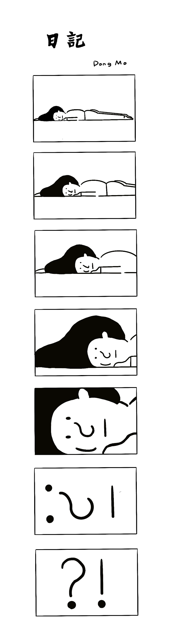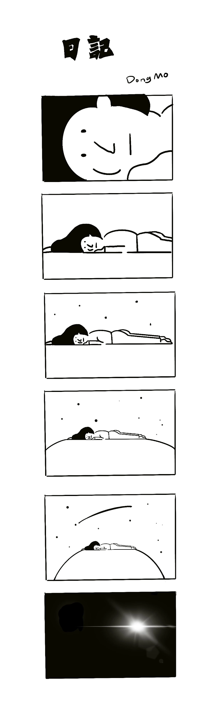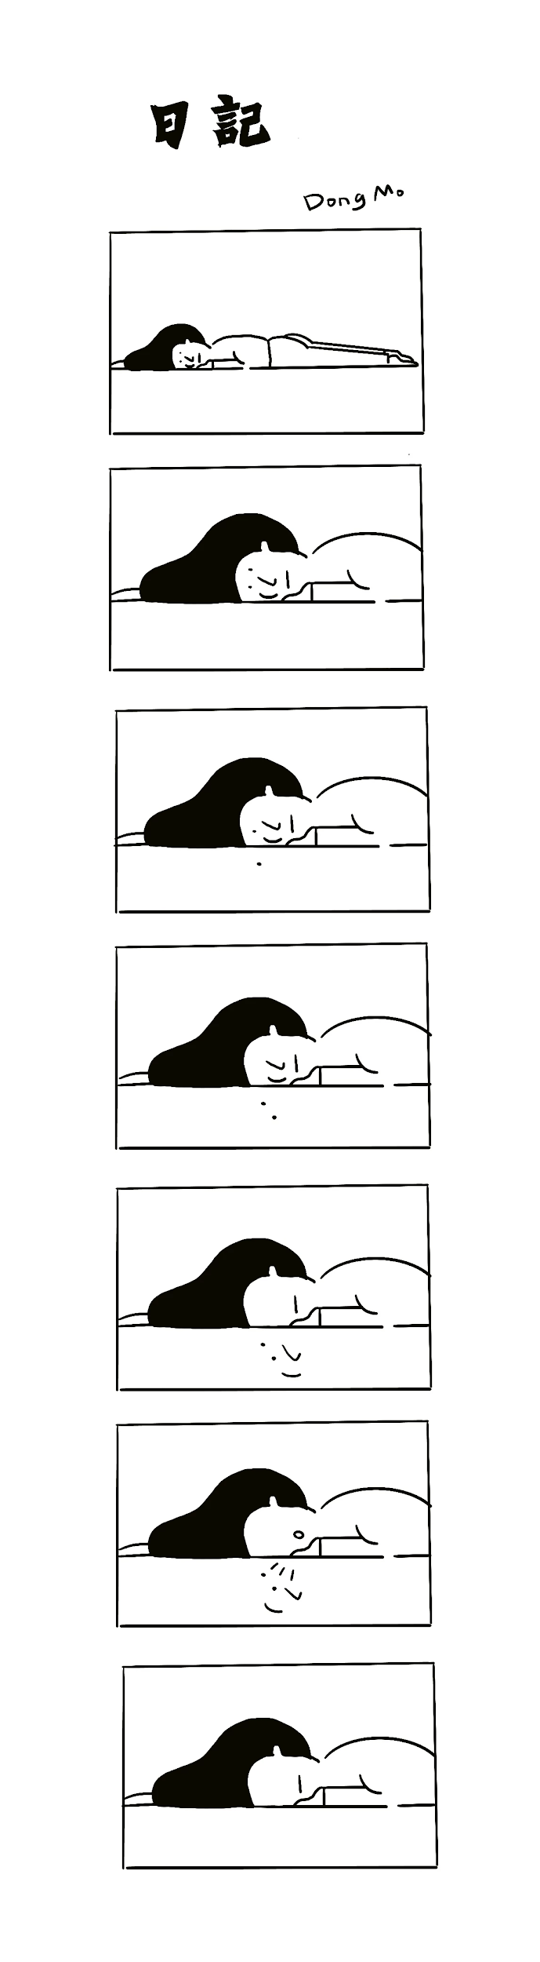
Comics by Dong Mo: #Stayathome for the country #The10thday (left), #The20thday #Dr.Li Wenliang died (center), and #The25thday

Submissions from Dong Mo, a professor in Xi’an, use a comic book aesthetic to convey the universally understandable feelings of helplessness and boredom during lockdown. For the average person, “fighting” Covid means embracing inactivity—as Dong writes in his post, “I can't seem to do anything, the only thing I can do is stay at home.” The corresponding feeling of powerlessness is conveyed as the cartoon character’s facial features slip off their face, or when the character is revealed to be just a tiny speck in the universe on the day of Dr. Li Wenliang’s death. While the passing of time is demarcated in the title of each comic, the central character occupies an identical posture in each, laying face-down in bed. Whether fifteen, twenty, or thirty days have passed since the start of lockdown, daily life looks remarkably similar in each. Sometimes it feels like the past year has gone by in a similar manner—days, weeks, months blurring together until, somehow, we found ourselves having orbited all the way around the sun.

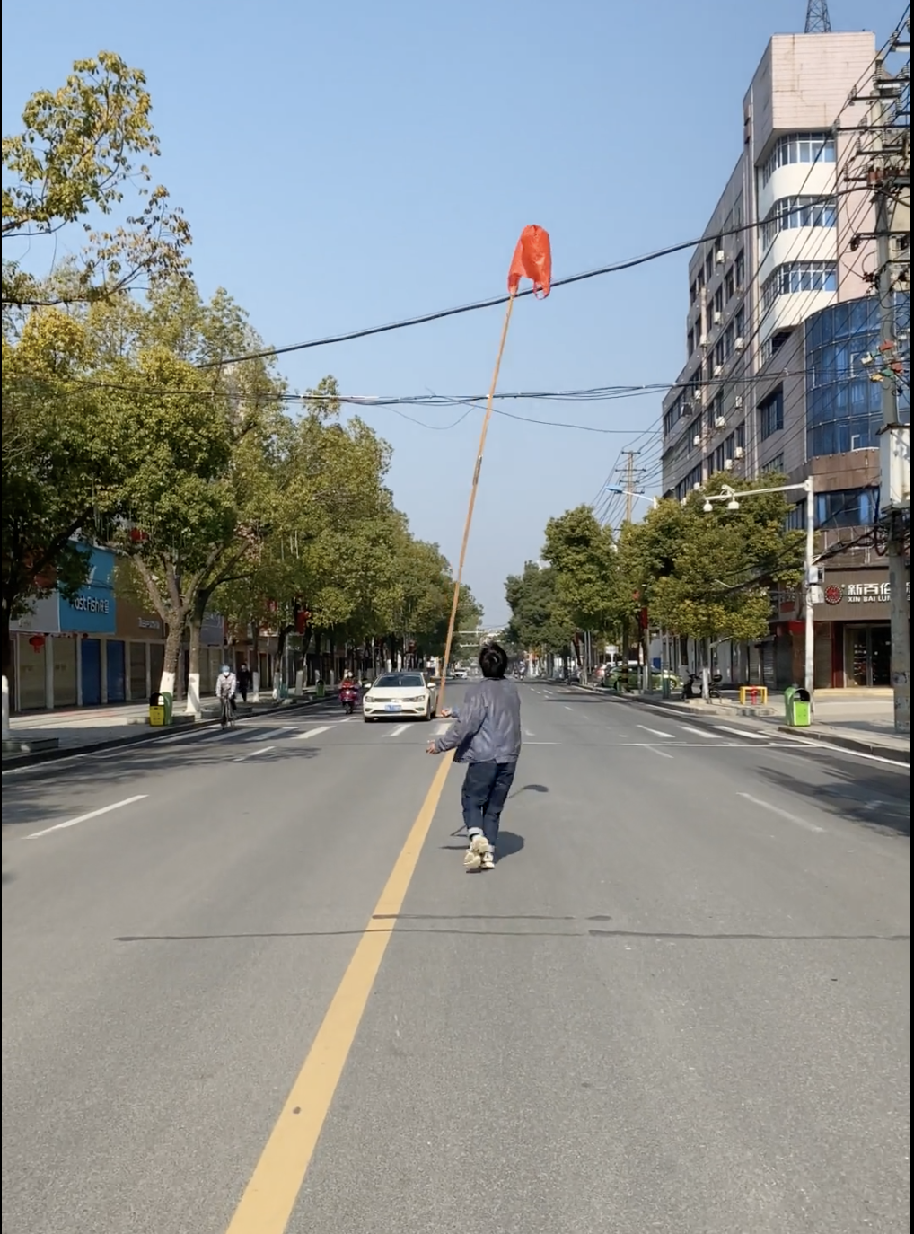
Still from Li Liao’s video submission

The theme of absurdity is picked up in Li Liao’s video submission from February 13, filmed in Hubei Province. During lockdown, people worldwide have experienced their normal surroundings become alien, especially as once-busy urban areas emptied out. Cities, planned and constructed for the efficient movement of people, suddenly became shadows of our past lifestyles. In the video, Li takes advantage of an unpopulated city-scape to wander in the middle of a road, balancing what appears to be a red shopping bag atop a tall stick. As the wind blows the bag around Li stumbles to keep up, weaving between the occasional vehicle on the road. People on mopeds turn their mask-covered faces to stare at the odd sight as they pass. But, when life as we know it is entirely changed overnight, is Li’s action actually that bizarre?

A year into Covid, initial feelings of upheaval have subsided somewhat and become normalized. Unable to go to school or work, our days have moved from classrooms and offices to video calls, accommodating the demands of neoliberal society. Adjustments to our lifestyles have re-imposed a feeling of normality into what are otherwise entirely strange circumstances. But Li’s video reminds us that, for a short time, the suspension of everyday life laid bare the absurdity embedded deep within our modern lifestyles.

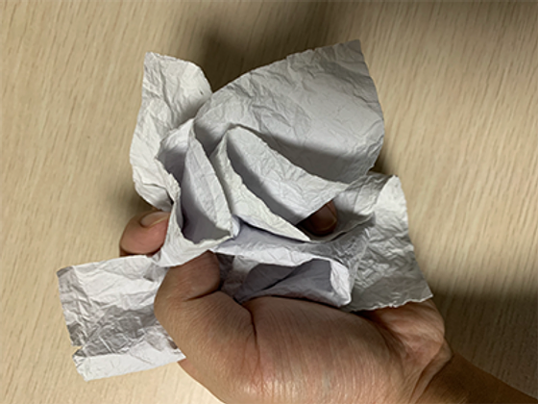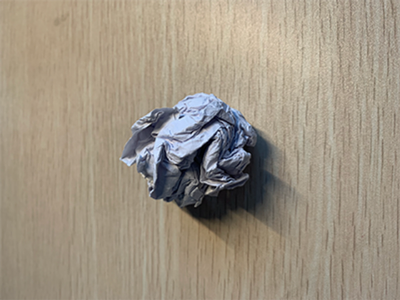
Ge Yelu’s submission

Of course, as a major historical moment, Covid-19 can be overcome but will never be erased from the global consciousness. Ge Yelu’s submission to Posts from the First Lockdown is subtle but moving; it consists of an A4 sheet of paper that the artist repeatedly crumpled up then ironed out in an attempt to revert it to its original state. The final result is a paper bearing creases and tears, pockmarked by the efforts of the artist’s hands. Ge’s work speaks to the lasting legacy Covid will leave on humanity. While we may get back to work due to the demands of global economies, or return to our families in person after receiving a vaccine jab, the traces of quarantine will remain embedded in human culture. The pandemic has already seen an increase in class inequality and a titanic shift towards digitization. In the personal sphere, it has seen a mental health crisis. Viewing Ge’s work one year later, I can’t help but wonder: after our bodies have been vaccinated, what scars will our lives bear?

As the vaccine rollout progresses and we inch closer to the highly anticipated “re-opening” of society, we are living in a timely moment to reflect on where we have been this past year. Beyond lifestyle changes, the legacy of Covid has already proven to have marked effects worldwide-- most recently through a string of violence targeting Asian bodied people, enacting anger sparked by racist imaginings of Covid as the “Chinese virus” or “kung flu”. Covid has inspired emotions of anger, powerlessness, and loss. Looking at the work of the Chinese artists participating in Posts from the First Lockdown is a reminder of the shared human experiences of the past year, which often transcend national boundaries. The works included will no doubt become valued as primary sources documenting reactions to the first of many lockdowns. In the present, however, they already exist as powerful reminders of the universality of human experience—proving that we have experienced the many emotions of this unusual time together, alone.

See Feng, Xiaodan. “Curating and Exhibiting for the Pandemic: Participatory Virtual Art Practices During the COVID-19 Outbreak in China.” Social Media + Society, (July 2020). https://doi.org/10.1177/2056305120948232.

